**BLOCK DIAGRAM :**

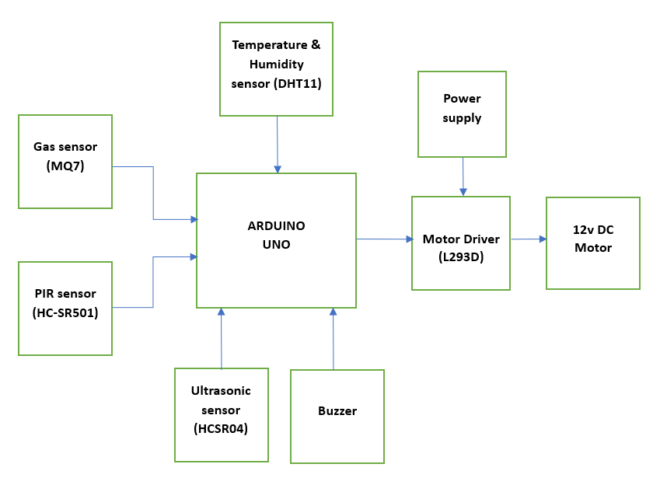

**RESULTS :**

**Hardware implementation :**

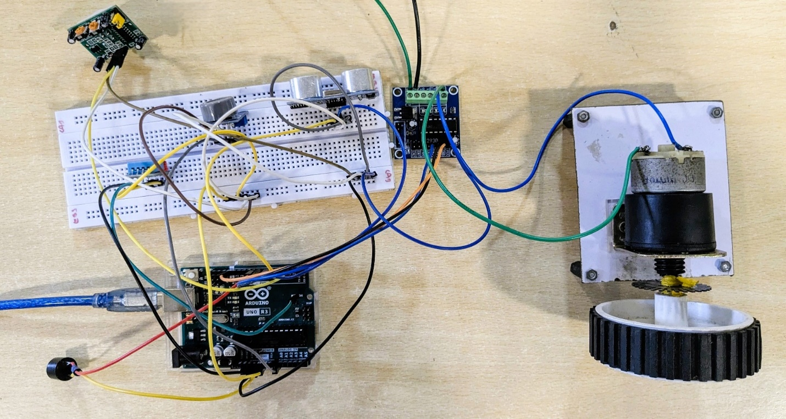

**TABULAR RESULT :**

|  |  |  |  |
| --- | --- | --- | --- |
| **S.no** | **Sensors** | **Input conditions** | **Output** |
| 1 | DHT11 sensor | 1. dht11 temperature > 25 degree | Fan on |
|  |  | 2. dht11temperature < 25 degree | Fan off |
| 2 | PIR sensor | 1. PIR sensor (No motion detected initially) | Fan off |
|  |  | 2. PIR sensor (Motion detected) | Fan on |
|  |  | 3. PIR sensor (No motion detected for a certain time, i.e. 10 minutes) | Fan off |
| 3 | Ultrasonic sensor | 1. If an object/obstacle distance is greater than fan distance by 30 cm | Fan on |
|  |  | 2. If an object/obstacle near the fan with a distance less than 30 cm | Fan off |
| 4 | MQ7 sensor | 1. If CO threshold level is greater than 350 PPM | Buzzer on |
|  |  | 2. If CO threshold level is less than 350 PPM | Buzzer off |